**Software Development Plan for MovieQ Project**

4.1 Plan Introduction

4.1.1 Project Deliverables

4.2 Project Resources

4.2.1 Hardware Resources

4.2.2 Software Resources

4.3 Project Organization

4.4 Project Schedule

4.4.1 PERT / GANTT Chart

4.4.2 Task / Resource Table

4.4.3 Class Schedule (optional)

**4.1 Introduction**

This Software Development Plan provides the details for the planned development of the MovieQ Database Project which provides an application for users to find out more about movies.

The application will provide a user on my laptop a command line interface to query 3 distinct database languages: PostGres uses Structured Query Language, Cassandra uses Cassandra Query Language, and Elastic Search uses the Query DSL. This project gives the user to directly experience the 3 languages and see which one is the easiest to learn. Additionally, the performance of the 3 database engines can be directly compared through comparing the speed at which each returns the same query. Development will require me to install all 3 programs on my computer, create a new database in each engine, import the same dataset into all of them, and then run them and see how they perform.

Tentative Schedule:

Requirements Specification Document -- Week 5

Software Development Plan -- Week 7

Re-submit Requirements Spec -- Week 13

Preliminary Demonstration Presentation -- Week 13

Final Delivery -- Week 16

**4.1.1 Project Deliverables**

PostgreSQL Command Line Interface

PostgreSQL will be accessed through a desktop application.

Cassandra Command Line Interface

Cassandra will be accessed through the command line by setting up a new instance of the shell.

Elastic Search Interface

The project will use Query Space in the UI which is accessed through a localhost port to search the db.

Project Proposal Document

* The proposal document has a list of the general goal of the project and how that goal will be executed.

Requirements Specification Document (Initial)

* The requirements document listed all of the functional requirements of my software project.

Software Development Plan

* The Development plan will contain information about when the software will be built.

Requirements Specification Document (re-submitted)

* The requirements document will be updated.

Preliminary Demonstration Presentations

* The demonstration will show how my software is used and will show that the requirements have been met.

Final Product Delivery

* The final product will be submitted to the instructor.

Final Project Presentation

* A final presentation will be made that has all of the required functionality.

**4.2 Project Resources**

I will be doing all of the development myself. The resources I will be using will be online articles and videos to help me correctly develop the software.

4.2.1 Hardware Resources

MacBook Pro (Retina, 13-inch, Early 2015)  
Processor: MacBook Pro (Retina, 13-inch, Early 2015)

Memory: 8 GB 1867 MHz DDR3

Graphics: Intel Iris Graphics 6100 1536 MB

4.2.2 Software Resources

PostgGreSQL->Posgres.app

Apache Cassandra

Elastic Search

**4.3 Project Organization/Human Resources**

N/A

**4.4 Schedule**

This section provides schedule information for the MovieQ project.

4.4.1 Pert Chart for MovieQ Project

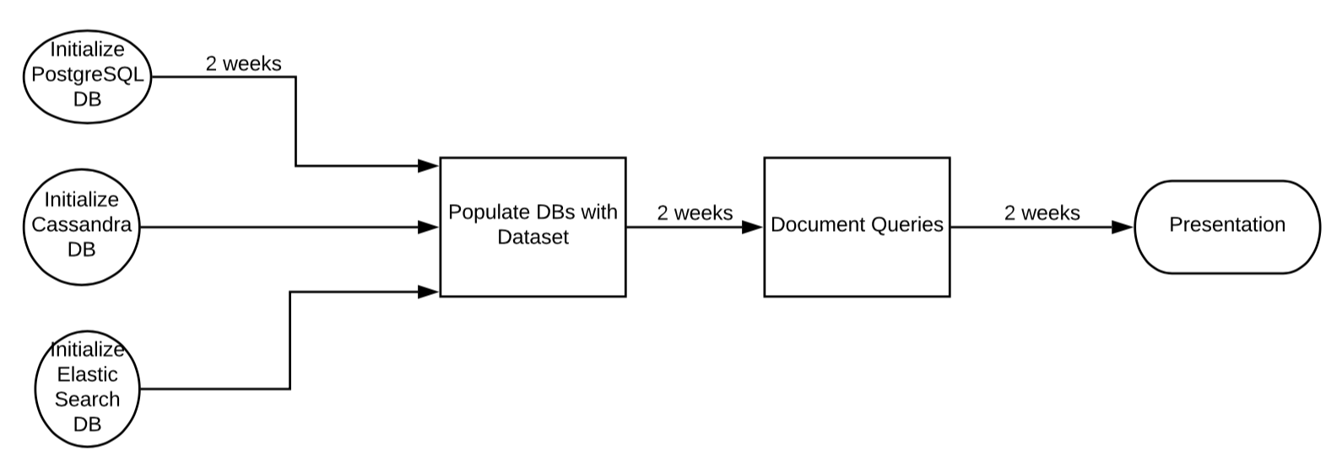

4.4.2 Task/Resource Table

|  |  |  |
| --- | --- | --- |
| Task | Hardware | Software |
| Initialize PostgreSQL | MacbookPro | Postgres App |
|  |  |  |